The *n*-queens puzzle is the problem of placing *n* queens on an *n*×*n* chessboard such that no two queens attack each other.

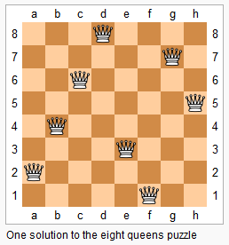

Given an integer *n*, return all distinct solutions to the *n*-queens puzzle.

Each solution contains a distinct board configuration of the *n*-queens' placement, where 'Q' and '.' both indicate a queen and an empty space respectively.

**Example:**

**Input:** 4

**Output:** [

[".Q..", // Solution 1

"...Q",

"Q...",

"..Q."],

["..Q.", // Solution 2

"Q...",

"...Q",

".Q.."]

]

**Explanation:** There exist two distinct solutions to the 4-queens puzzle as shown above.